Lab56:
Create a stored procedure that uses both scalar and table-valued functions.
1. Modify Scalar Function to Include Bonus:
- create a scalar function named CalculateTotalCompensation which will take salary as a parameter and returns a decimal value.
- @Salary DECIMAL(10, 2): This is an input parameter for the function. It specifies the salary.
- Declare a bonus variable @Bonus DECIMAL(10, 2) to store the calculated bonus.
- SET @Bonus = @Salary * 0.10- calculates the bonus as 10% of the salary and assigns it to the @Bonus variable.
- RETURN @Salary + @Bonus- this returns the total compensation which is the sum of salary and the bonus here.
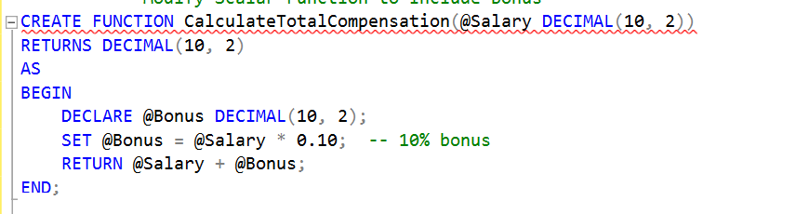

2. Create a Stored Procedure to Retrieve High Earning Employees with Total Compensation:
Create a stored procedure named GetHighEarningEmployeesWithCompensation which will have two paramters as input @Department and @MinSalary which are required to pass while calling this function.
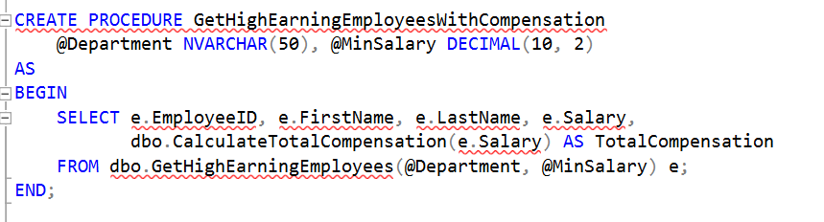

This SELECT statement retrieves columns (EmployeeID, FirstName, LastName, Salary) from the result set of the GetHighEarningEmployees function.
Pass the department as a parameter in a GetHighEarningEmployees (@Department, @MinSalary), this will call the function.

3. Execute the Stored Procedure:
This command calls the GetHighEarningEmployeesWithCompensation stored procedure.
And passes IT and 7000 to the procedure parameter. As a result, it retrieves employees with a salary greater than 70000.
